**Chapter 10 - Evolution**

**All Lectures Uploaded on YouTube:**

[**https://tinyurl.com/fkm9-biology**](https://tinyurl.com/fkm9-biology)



## The number of species of living things on earth currently exceeds a million. Each species has its own manner of living and working. Some species appear to be highly similar to one another, whereas others do not.

## **10.1 Variation and Evolution**

Variation and evolution are closely related concepts. Variations provide the raw material for evolution, while evolution is the gradual change in organisms over generations due to these variations.

### **10.1.1 Variation**

Variation refers to the differences found among individuals of the same species. No two individuals are exactly alike, except identical twins.

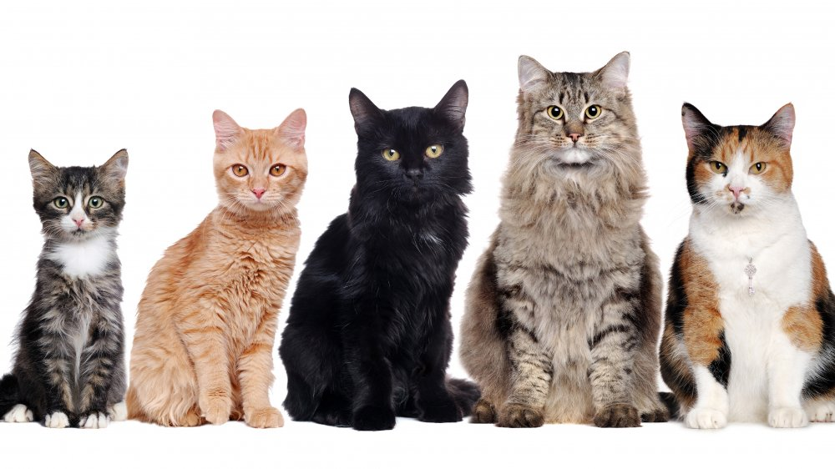

**Causes of Variation:**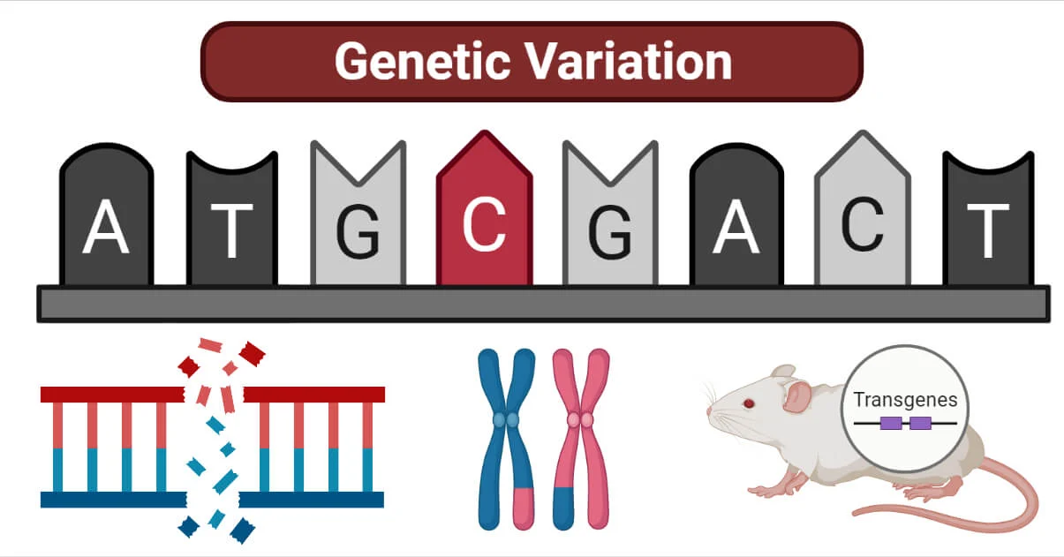

• Genetic variation due to differences in DNA  
• Errors during DNA copying  
• Sexual reproduction which mixes genetic material  
• Environmental factors such as climate, food, and lifestyle

**Importance of Variation:**

• Helps organisms adapt to changing environments  
 • Increases chances of survival of a species  
 • Forms the basis of evolution

### **10.1.2 Evolution**

Evolution is the gradual change in the characteristics of organisms over many generations, resulting in the formation of new species.

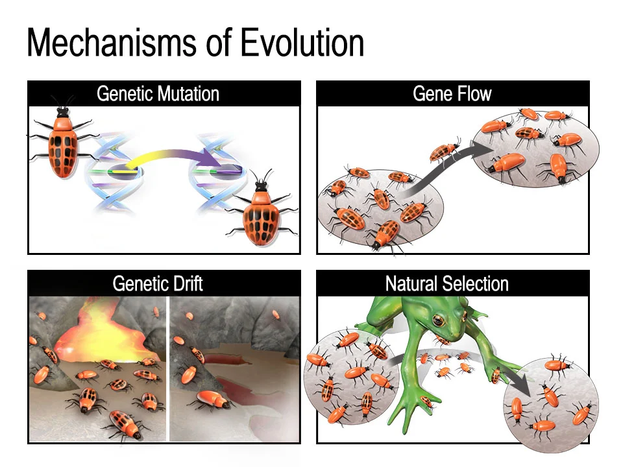

Some individuals of a population may have an advantage over other members as a result of population variations. These individuals will be able to have more progeny. Consequently, the population will gradually see more instances of that specific variant. With these variations, they will have a better chance of surviving and procreating.

Evolution occurs due to:  
 • Accumulation of useful variations  
 • Natural selection  
 • Environmental changes  
 • Genetic drift over long periods of time

### **10.1.3 Theory of Natural Selection**

Natural selection is the process through which organisms who possess traits that are helpful for reproduction in a certain environment produce more children in the following generation. As a result, they gradually expand the population's genetic diversity.

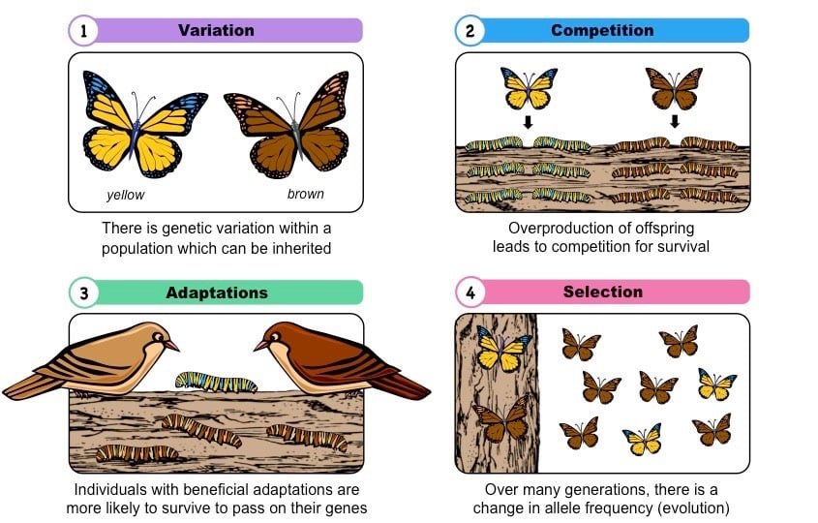

The Theory of Natural Selection was proposed by Charles Darwin. After a five-year voyage around the world in the ship HMS Beagle, Charles Darwin put forth the Theory by Natural of Natural Selection" Selection recording in 1838. In 1859, he released a book titled "On the Origin of Species his observations. According to this theory:

• Organisms produce more offspring than can survive  
 • There is variation among individuals  
 • Due to limited resources, there is a struggle for existence  
 • Individuals with favourable variations survive and reproduce  
 • Unfavourable variations are eliminated  
 • Over time, favourable traits become common in the population

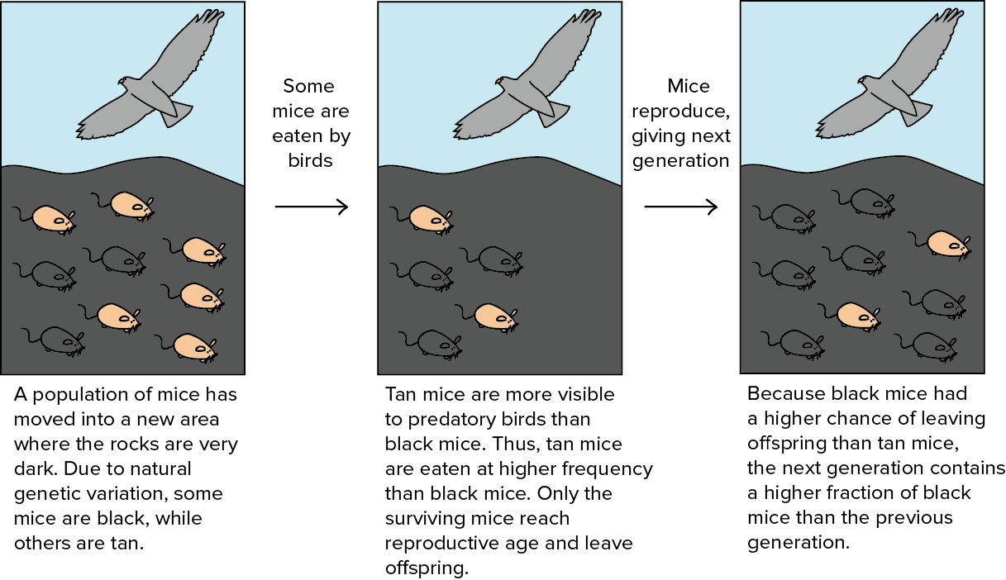

During his 1835 visit to the Galápagos Islands, Charles Darwin observed that animals like finches and tortoises varied significantly from island to island, each perfectly adapted to its specific environment, with distinct beak shapes (finches) and shell shapes (tortoises) related to available food, sparking his revolutionary ideas about evolution by natural selection from mainland ancestors, as these creatures were similar yet unique.

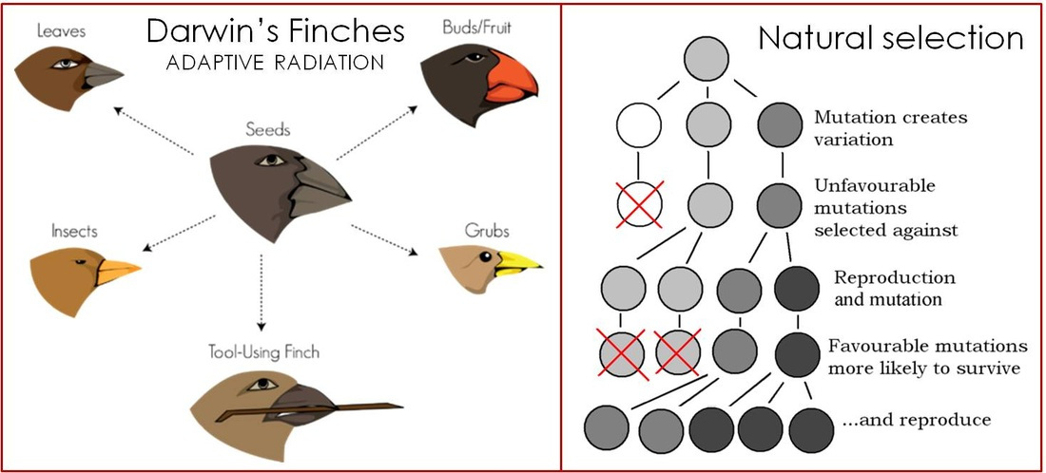

Natural selection causes population-wide changes in gene frequencies over time; as a result, individuals with more advantageous traits will be more prevalent in the population and individuals with less advantageous traits will be less prevalent.

### **Case Study: Variation and Selection**

Industrial melanism refers to the evolutionary phenomenon in which darker-coloured forms of organisms become more common in industrial areas due to environmental changes caused by pollution. The classic and most well-documented example of industrial melanism is seen in the peppered moth (*Biston betularia*) in England.

The peppered moth exists in two main forms:

* **Light-coloured (typical)** form, which has pale wings with dark speckles
* **Dark-coloured (melanic or carbonaria)** form, which has almost black wings

Before the Industrial Revolution (pre-1850), the light-coloured moths were abundant. At that time, tree trunks were covered with light-coloured lichens, and the pale moths were well camouflaged against predators such as birds. Dark moths were rare because they were easily visible on the pale tree bark and were eaten more frequently.

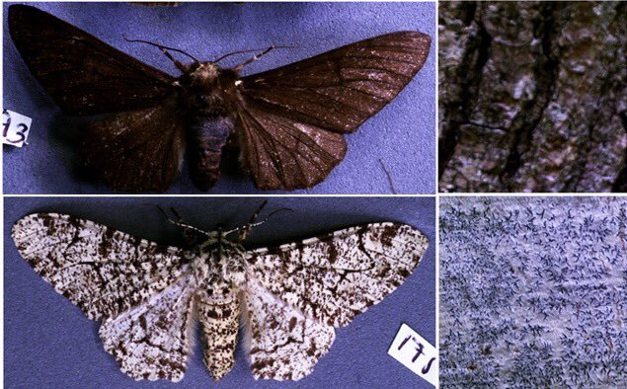

During the Industrial Revolution, large amounts of soot and smoke from factories settled on trees, killing lichens and darkening tree trunks. In this polluted environment, the **dark-coloured moths gained a survival advantage**. They were better camouflaged on the blackened tree bark, while light-coloured moths became more visible and were preyed upon more easily. As a result, the population of dark moths increased rapidly, and they became the dominant form in industrial regions.

When pollution levels decreased in the mid-20th century due to environmental laws, tree bark gradually became lighter again, and lichens returned. Consequently, the light-coloured moths once again gained a survival advantage, and their population increased while the dark form declined.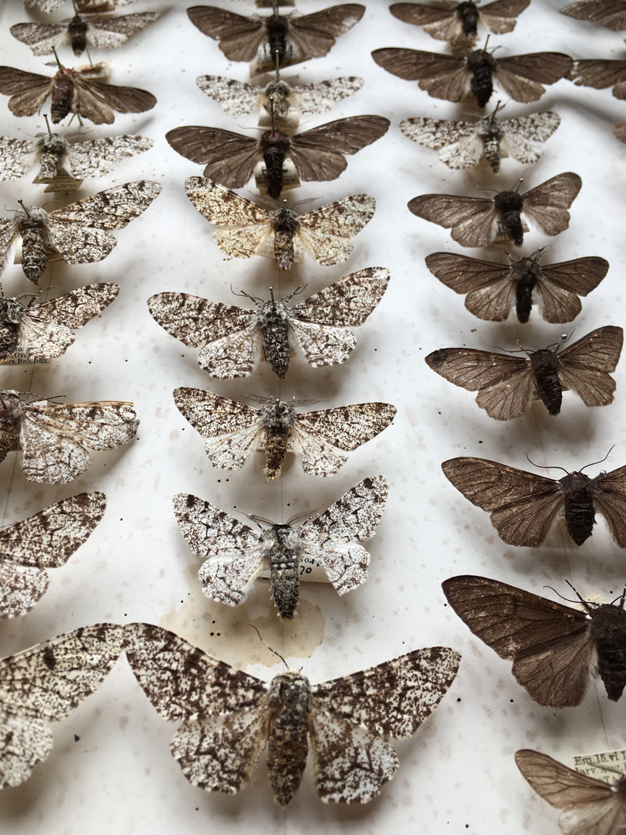

**Why this is strong evidence of natural selection:**

1. **Variation** existed in the population (light and dark forms).
2. **Environmental change** (industrial pollution) altered survival conditions.
3. **Differential survival** occurred, as birds preferentially preyed on more visible moths.
4. **Inheritance** of colour traits allowed successful moths to pass on their genes.
5. **Change in population frequency** over generations was observed.

Thus, industrial melanism in the peppered moth clearly demonstrates natural selection in action, where environmental pressures directly influence survival and reproduction, leading to evolutionary change in a population.

## **10.2 Evidences of Evolution**

Evolution is supported by strong scientific evidence collected from different branches of biology. These evidences prove that present-day organisms have evolved gradually from earlier, simpler forms and share common ancestors.

### **10.2.1 Evidence from Paleontology**

Paleontology is the branch of science that deals with the study of fossils. Fossils are preserved remains, impressions, or traces of organisms that lived in the past, usually found embedded in sedimentary rocks.

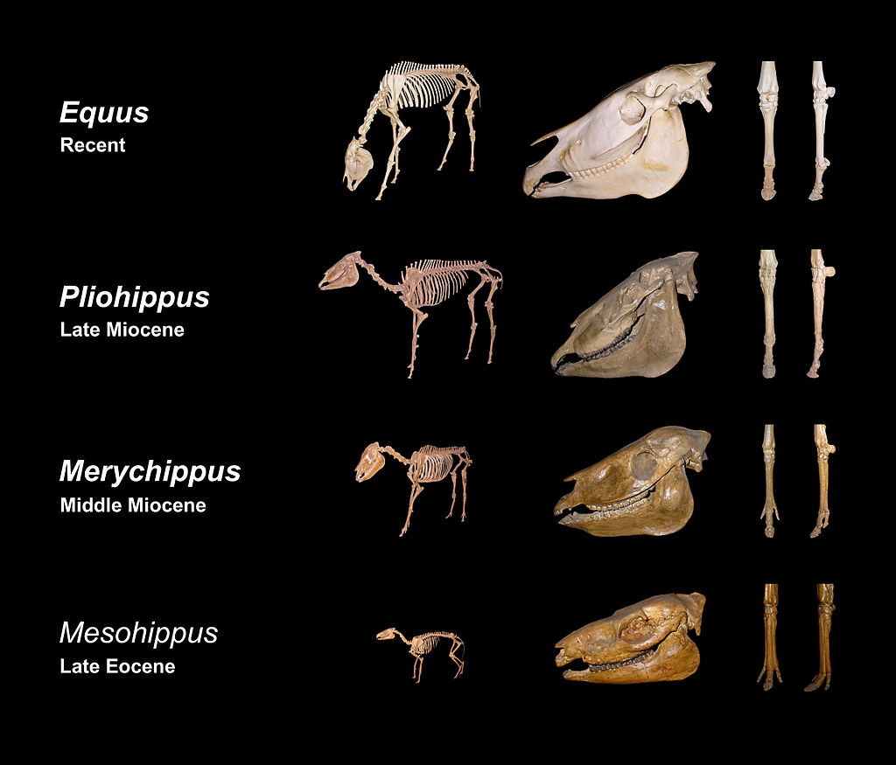

**Importance of Fossils as Evidence of Evolution:**

• Fossils provide direct evidence of organisms that existed millions of years ago.  
 • They show gradual changes in structure over long periods of time.  
 • Simple organisms are found in older rock layers, while complex organisms are found in recent layers.  
 • Fossil records help scientists arrange organisms in an evolutionary sequence.

**Transitional Fossils:**

• Transitional fossils show characteristics of both ancestral and modern organisms.  
 • Example: Archaeopteryx shows features of both reptiles (teeth, long tail) and birds (feathers, wings).

### **10.2.2 Evidence from Comparative Anatomy**

Comparative anatomy is the study of similarities and differences in the structure of organs among different organisms. Structural similarities indicate common ancestry.

**Homologous Organs:**

• Organs that have the same basic structure and origin but perform different functions.  
 • Indicate divergent evolution.  
 • Example: Forelimbs of humans, whales, bats, and cats.

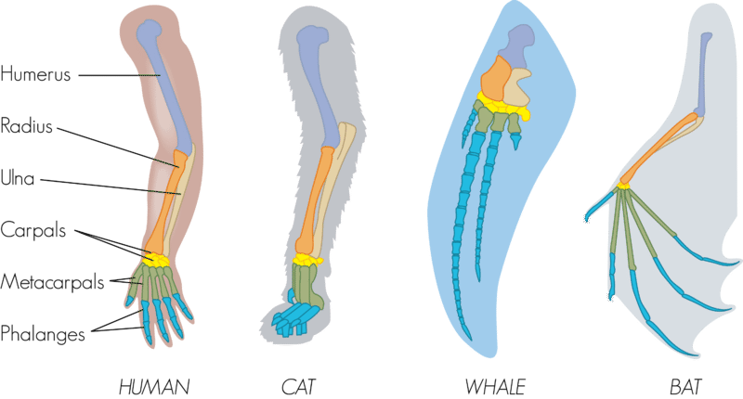

**Analogous Organs:**

• Organs that perform similar functions but have different origins and structures.  
 • Indicate convergent evolution.  
 • Example: Wings of birds and insects.

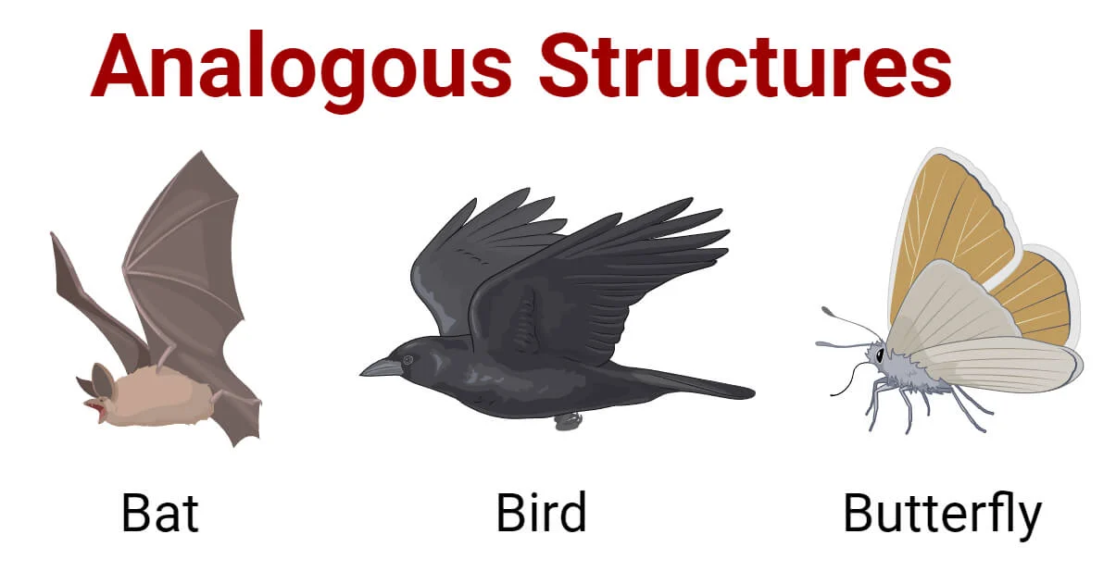

**Vestigial Organs:**

• Reduced or non-functional organs present in organisms.  
 • These organs were functional in ancestors but lost their function over time.  
 • Example: Appendix in humans, hind limb bones in whales.

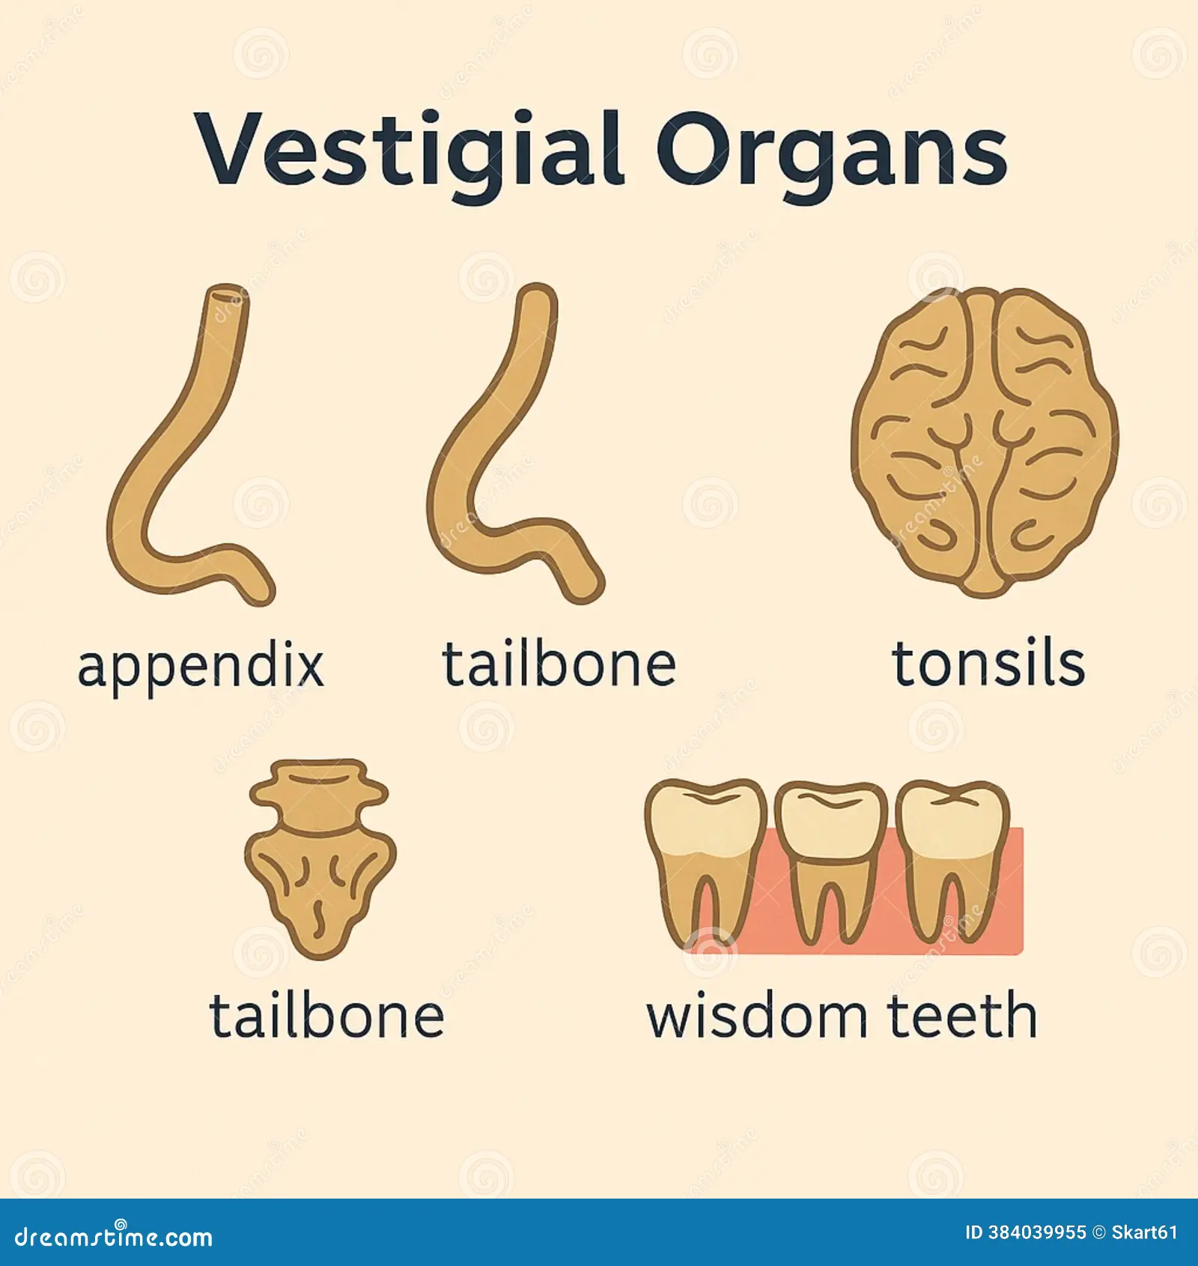

### **10.2.3 Evidence from Selective Breeding**

Selective breeding is a process in which humans intentionally select organisms with desirable traits for reproduction. Over generations, this leads to noticeable changes in the characteristics of species.

**Significance as Evidence of Evolution:**

• Shows that selection can cause changes within a species.  
 • Demonstrates how variation already present in a population can be enhanced.  
 • Supports the idea that long-term natural selection can lead to evolution.

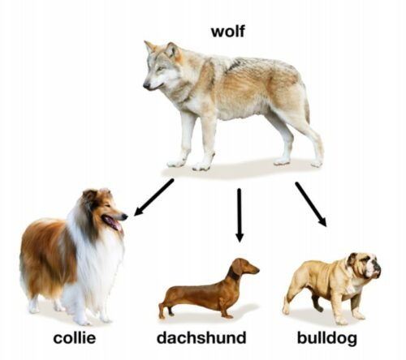

### **10.2.4 Improving Plants by Selection**

Plant breeding involves selecting plants with desirable characteristics and allowing them to reproduce to obtain improved varieties.

**Traits Selected in Plants:**

• High yield  
 • Early maturity  
 • Disease and pest resistance  
 • Drought and flood tolerance  
 • Improved nutritional quality

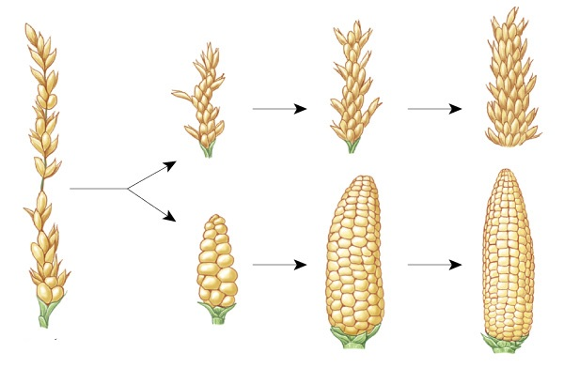

**Examples:**

• High-yielding varieties (HYV) of wheat and rice.  
 • Disease-resistant crop varieties.

### **Improving Animals by Selection**

Animal breeding is done to enhance economically and socially important traits.

Traits Selected in Animals:  
 • Higher milk yield in cattle  
 • Better wool quality in sheep  
 • Faster growth rate in poultry  
 • Disease resistance

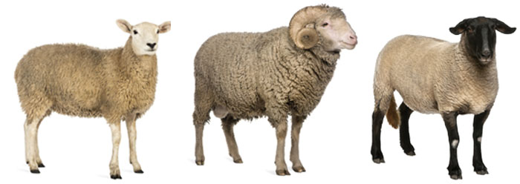

### **Natural vs Artificial Selection**

**Natural Selection:**

• Occurs naturally without human intervention.  
 • Environmental factors select the most suitable organisms.  
 • Leads to adaptation and speciation over long periods.

**Artificial Selection:**

• Controlled by humans.  
 • Selection is based on human needs.  
 • Produces rapid but limited changes.

## **10.3 Speciation**

Speciation is the evolutionary process where populations diverge to form new, distinct species, driven by genetic changes and reproductive isolation, often through geographic separation (allopatric) or occurring within the same area (sympatric), resulting in different environments or lifestyles preventing successful interbreeding, ultimately leading to Earth's biodiversity.

**Causes of Speciation:**

• Geographical isolation: A physical barrier (mountains, rivers) separates a population, leading to different evolutionary paths.  
 • Genetic variation  
 • Natural selection: Adapting to different environments or pressures, favoring certain traits.  
 • Reproductive isolation: New species evolve from a single ancestral species while inhabiting the same geographic region, often due to chromosomal changes. Populations can no longer successfully breed, solidifying them as separate species.





